**DEEPER LIFE HIGH SCHOOL**

**CULTURAL AND CREATIVE ART SCHEME OF WORK**

**JS 1(BASIC 7) SECOND TERM**

**WEEK TOPIC**

1. Collage production: i. meaning of collage ii. Materials for collage iii. Methods of producing collage.
2. Modeling with papier-mâché: i. meaning of papier-mâché/clay ii. Materials made from clay and papier-mâché(plates, cup, decorations, vase, hangings, molded animals etc)
3. Process of modeling using clay/papier-mâché: i. papier-mâché production ii. Using papier-mâché to mold an object
4. Bead work: i. definition of bead ii. Uses of beaded jewelry iii. Production of bead using (roll paper, seeds, straw and bottle tops).
5. Mosaics : i. meaning of mosaic ii. Materials/tools for making mosaic iii. Uses of mosaic
6. Mosaic: i. making of mosaic project (Practical).
7. **Mid Term**
8. Theory of music (a. Fundamentals of Music) i. definition of music, sources of sound, musical sound, characteristics of sound (pitch, intensity etc.), musical notation.
9. Theory of music: i. Elements of music (pitch, melody, harmony, rhythm, texture, timbre, form of structure) ii. Notes on keyboard (a) ear training and harmony (Practical)
10. Rudiment of music: i. musical alphabets ii. Clef and names of staves iii. Types of staff i.e.Treble, bass, great stave iv. Musical notes and relative values v. major scale of C natural-definition, application. vi. Uses of music: i. uses ii. Impact of music.
11. Revision
12. Examination.

**WEEK 1**

**Date:…………………………..**

**COLLAGE PRODUCTION**: i. meaning of collage ii. Materials needed for collage production iii. Steps in collage production.

**MEANING OF COLLAGE**

Collage is a work of art in which pictures are built up using bits and pieces of different types of materials.

It is a two dimensional art.

Collage as work of art was developed by French painter George Braque and the Spanish artist Pablo Picasso.

**MATERIALS FOR COLLAGE PRODUCTION**

1. Cardboards
2. Pieces of coloured paper
3. Scissors
4. Blade
5. Adhesive (evostic, glue, or any other form of gum)
6. sand
7. Wood
8. Egg shell
9. Cowries etc.

**STEPS IN COLLAGE PRODUCTION**

1. Decide on which design or picture to be used.
2. Make sketches of designs or pictures you intend to use
3. Pick one out of the designs or picture sketch and improve on it.
4. Present or show the chosen design or picture to your teacher for correction and approval.
5. Transfer with pencil, your design or picture onto the background support
6. Cut or trim the pieces of coloured paper you intend to use to sizes
7. Start applying adhesive onto the reverse side of each of the coloured paper and paste to bring out the form of design or picture you have drawn on the background support.
8. Continue until the design or picture is properly formed.

**USES OF COLLAGE**

1. Paper collage is use for decoration
2. It is used for child art
3. Paper collage is used as instructional material
4. Paper collage making can be used to display the general knowledge of collage making.

**EVALUATION**

1. What is collage?
2. What are the steps to collage production?

**Reading assignment**

A proper Approach to Cultural and Creative Art for Junior Secondary School book 1 by Peter Akinyemi page30-31.

WEEKEND ASSIGNMENT

1. The work of Art in which pictures are built up using bits and pieces of different type of materials is called_______
2. Collage B. Mosaic C. Papier-mâché D. modeling
3. One of these artist developed collage
4. Michealangelo B. Rembrandt C. Braque D. Seurat
5. One of these is not true of collage
6. Cardboard B. Scissors C. Adhesive D. Stetoscope
7. Uses of collage includes all except ________
8. For decoration B. For child art C. For instructional materials D. For game
9. Steps to collage production includes all except
10. Decide on which design or picture to be used
11. Make sketches of designs or picture you intend to use.
12. Pick one out of the designs or picture sketch and improve on it
13. Pound the paper with Mortar and Pestle.

**[1]WEEK 2**

**Date:…………………………..**

**TOPIC: MODELLING WITH PAPER MACHE:**

1. Meaning of papier-mâché/clay
2. Materials made from papier-mâché/clay

**MODELLING**

Modeling is the art of molding objects with different materials like papier-mâché clay, plasticine, cement etc.

**MEANING OF PAPIER-MÂCHÉ**

It is a process of making pulp from paper (old newspaper, cardboard sheets or tissue paper) used for modeling objects.

Papier-mâché is re-pulped paper mixed with glue or paste used to mould objects.

It is a French word which means mashed paper used to produce modeled objects.

**MEANING OF CLAY**

Clay is an earthen material used for molding.

**MATERIALS AND TOOLS NEEDED FOR PAPIER-MÂCHÉ**

Old newspaper, old Calendars, tissue paper.

(ii) Water

(iii) Starch

(iv) vegetable oil or grease

(v) Scissors/cutter

(vi) Mortar and pestle

(vii) Bowl

(viii) Spoon

(ix) Paint

(x) Brush

(xi) Spatulas.

**PREPARATION AND THE MAKING OF PAPIER-MÂCHÉ FOR MODELLING**

1. Cut the paper into small bits or strips, approximately ½ in wide.
2. Soak the small bits of papers inside water for at least 24 hours. (tissue paper should be soaked for few minutes)
3. Remove the soaked pieces of paper and squeeze out the excess water.
4. Pound the soak paper inside Mortar and Pestle. (tissue paper may not be pounded because it is already soft)
5. Remove the pounded pulp from the Mortar into a bowl.
6. Prepare cassava starch with hot water and mix to a fairly thick consistency (like the preparation of pap)
7. Mix the paper pulp with the starch properly when the starch is cool (white glue can also be used in place of starch).

The prepared pulp can be used to mould objects like bowl, cup, jugs, animals etc.

**DIP AND PASTE METHOD OF PAPER-MACHE MODELLING**

The technique involves the cutting of papers into strips, soaking them in the prepared starch and laying the stripes on the greased surface of a plate or bowl that will serve as the mould that the dry paper will take its shape. The surface of the plate can be greased with vegetable oil or grease.

**USES OF PAPIER-MÂCHÉ**

1. Papier-mâché modeling can be used to teach students about three dimensional shapes and form.
2. Objects made from papier-mâché can be used as teaching aids in laboratory and classroom.
3. Papier-mâché modeling can be used to teach the student how to manage waste in our environment.
4. Papier-mâché can also be used as an avenue to teach improvisation in art class.
5. Papier-mâché products can be used for decoration.

**PERIOD 2**

Practical work on papier-mâché.

**EVALUATION**

Explain the term, modeling

Define papier-mâché

Explain how you can prepare papier-mâché for modeling

Mention two uses of papier-mâché

**Reading Assignment**:

A proper approach to Cultural and Creative Art for junior secondary school book 1. Page29-31.

**WEEKEND ASSIGNMENT**

1. Plates are used as ______in the dip and paste method of papier-mâché production (a) containers (b) models (c) mould (d) starch
2. Papier-mâché is re-pulped paper mixed with ________ or _________ to mould
3. papier-mâché is a _____ word which means mashed paper used to produce modeled objects. (a)French (b) English (c) Latin (d) Portuguese
4. Examples of materials and tools needed for papier-mâché are ____ and _______ (a) water and starch (b) soap and sponge (c) Tire and tube (d) glass and wiper
5. One of the following is not a material for modeling in art. (a) papier-mâché (b) clay(c) glass (d) plasticine

ESSAY QUESTION

Explain the preparation of papier-mâché for molding object

Mention at least five materials and tools needed for papier-mâché

**WEEK 3**

Practical work

Produce the following with papier-mâché

1. Mask
2. Cup
3. Bowl
4. Pyramid

**READING ASSIGNMENT**

Cultural and creative Arts for Junior Secondary School by S.C. Nguma. Chapter 10, page 46-51

**WEEKEND ASSIGNMENT**

1. Plates are used as ______in the dip and paste method of papier-mâché production (a) containers (b) models (c) mould (d) starch
2. Papier-mâché is re-pulped paper mixed with ________ or _________ to mould
3. papier-mâché is a _____ word which means mashed paper used to produce modeled objects. (a)French (b) English (c) Latin (d) Portuguese
4. Examples of materials and tools needed for papier-mâché are ____ and _______ (a) water and starch (b) soap and sponge (c) Tire and tube (d) glass and wiper
5. One of the following is not a material for modeling in art. (a) papier-mâché (b) clay(c) glass (d) plasticine

ESSAY QUESTION

1. Explain the preparation of papier-mâché for molding object.
2. Mention at least five materials and tools needed for papier-mâché.

**WEEK 4**

**TOPIC: BEAD WORK**

(a) Definition of beads

(b) Production of beads

(c) Uses of beads.

Beads are small perforated objects made of different material, colours, shapes and sizes that may be strung into necklaces and bracelets or attached to clothing or furnishings. The word ‘bead’is derived from Middle English *‘bede’* meaning ‘prayer’ and was originally applied to prayer beads, or rosaries.

**USES OF BEADS**

1. Beads are used by some renown artists in design and portrait making
2. Beads are used for making shoes, purses and hand bag.
3. They are also used as necklaces, bracelets and anklets for adornment.
4. Beads are equally used for making crown and decorating the base of most royal staffs.
5. Beads are used for rosaries.

**PRODUCTION OF BEADS**

Beads are usually made of variety of materials such as seeds, wood, ivory, bone, horn, shell, pearl, gemstones, metals, ceramics, plastics etc. The main materials are beads and thread. Bead works can be located in Bida, among the Nupe people of Niger State in Nigeria.

There are different ways/forms of producing improvised beads. These include:

(i) Roll paper beads

(ii) Straw beads

(iii) Seed beads

(iv) Bottle tops/cover beads

EVALUATION

1. Define beads
2. State four uses of beads
3. List 4 ways of producing improvised beads

**READING ASSIGNMENT**

LOWO A. DAVID (2012) Eraz cultural & creative Art for JSS 1 Page 68

WEEKEND ASSIGNMENT

1. Bead is derived from a_______ word. (a) Nigerian (b) American (c) Middle English (d) Greek.
2. The word “*bede’’* means_______ (a) Church (b) Worship (c) Sporting(d) Praying.
3. Which of these is not a material used to produce beads? (a) Flower (b) Seeds (c) Plastics (d) Ceramics.
4. One of the uses of beads is/as____ (a) Necklace (b) Playing (c) Writing (d) Painting.
5. Among which of the following people can bead works be found? ______(a) Oshogbo (b) Nupe (c) Calabar (d) Indian.
6. Which of these is TRUE about beads? (a) Small perforated objects, usually spherical, that may be strung into necklaces and bracelets(b) Small stones used in building houses (c) Coloured substances used for make-up (d) Iron frames for framing photographs
7. One of the uses of beads is for decoration (TRUE/FALSE)
8. In traditional communities, beads are used as _______ (a) Amulets and necklaces (b) Caps and head ties (c) Shirts and trousers (d) Chairs and tables.
9. ONE of these does not belong to the group. (a) Roll paper beads (b) Straw beads (c) Pencil beads (d) Seed beads
10. Metal and plastics can be used for the production of beads. (TRUE/FALSE)

**WEEK 5**

**TOPIC: MOSAIC**

1. meaning of mosaic
2. materials and tools in making mosaic
3. uses of mosaic

**MEANING OF MOSAIC**

Mosaic is a type of inlaid design composed of stone, metals, glass, beads etc generally used for decoration. Mosaic is one of the most durable forms of decorative art of embellishing or decorating a surface such as floor or wall. Mosaics have a rough texture.

**MATERIALS AND TOOLS FOR MOSAIC**

Materials and tools for making mosaic include beads, stones, pebbles, glasses, broken bottles, dress buttons, glue, gum, paint brush, knife, pair of scissors, ruler, plywood, hardwood and strawboard.

**THE PRODUCTION OF MOSAIC WORK.**

In producing a mosaic work, the following steps should be followed:

Step 1: find different mosaic object.

Step 2: sketch or draw the desired image on a flat surface.

Step 3: cut or break the materials sourced in step 1 into pieces for usage.

Step 4: apply strong glue or gum to the surface.

Step 5: arrange the materials on your drawing according to plan. Continue this process until the desired image or form is obtained.

**USES OF MOSAIC.**

1. Mosaics are used in producing wall decorations
2. Mosaic replaces the use of colours in painting picture.
3. It is a method of creating forms such as mask.
4. It is less expensive since most of the materials can be found readily.
5. It encourages patience and endurance in students.
6. It creates a beautiful effect when viewed from a distance.

**EVALUATION.**

* 1. State five reasons why mosaic decoration is important in art.
  2. Explain the meaning of mosaic
  3. State five (5) materials and tools for mosaic.
  4. what are the steps to be taken in producing a mosaic design?

**WEEK 6 TOPIC: MOSAIC. PROJECT WORK: Practical production of various designs of mosaic work supervised by Educators.**

**WEEK 7**

**MID-TERM BREAK**

**WEEK 8**

**Topic:** Theory of music

**Content**

(a) Fundamentals of Music.

(i) Theory of music (language and notation, and element of music)

**Sub -Topic 1: fundamentals of music and sound.**

Music can be defined as a composition of organized sound pleasant to the ear.

It is a performing art, a medium in which one’s mind can be meaningfully expressed by who appreciates it:

The raw material of music is sound. Sound may be perceived as pleasant or unpleasant. Pleasant sound is musical sound while unpleasant sound is noise. Recorded music blared from a number of outlets (e.g. Business centers, shops etc) constitute noise. On the other hand, the sound from a performing orchestra could be very soothing and exhilarating.

The real difference between musical sound and noise lies in the impression made on the listener. While musical sound is generally attractive and enjoyable, noise is distracting and could be irritating. Furthermore, musical sound is organized while noise is not.

**Sources of sound**

There are two main sources of sounds:

1. Natural Source e.g. Human beings, animals, weather etc.
2. Artificial source – man with the aid of objects called musical instrument e.g. Guitar, gong etc.

**Musical sounds**

Musical sounds are produced in two ways:

1. Through the human voice (vocal music) and
2. Through musical instruments.

**CHARACTERISTICS OF SOUND.**

1. **PITCH:** This is the height or depth of a musical sound. E.g d:m:s:s:l:s-
2. **INTENSITY:** This refers to the loudness or softness of a musical sound.
3. **TIMBRE:** This is the difference in sound production of one musical instrument and the other. E.g the sound of violin differs from the sound of guitar, while the sound of guitar differs from that of saxophone.
4. **DURATION:** The length of a musical sound is called duration. In a piece of music, each sound has length(duration) in note beat value combined, in relation to other set of organized sounds to produce music.
5. **ACCENT:** This is the emphasis placed on certain sounds in a piece of music in order to create definite effects on the listeners or audience.

**Evaluation**

1. Define music
2. What is the difference between music and noise.
3. List three characteristics of sound.

**Sub – Topic 2: MUSICAL NOTATION**

Music notation simply refers to the system of reproducing musical sounds in writing. It is simply the art of writing music.

**Types of Music Notation**

There are several methods of writing music, but at this level, we shall study only two types: staff Notation and Solfa Notation.

**Solfa notation** involves the use of musical sounds such as **d;r:m:f:s :l:t:d**. Whenever we write musical sounds with these seven letters, it is solfa notation.

**Staff notation** is the method of writing musical sounds on the staff or staves using symbols called musical notes, e g.

A Staff is also called stave. It consists of five horizontal lines and four spaces between the lines, e g.



The lines and spaces of the staff are counted upwards beginning with the lowest.

Music is thus written on the lines and in the spaces of the staff as shown below.



**Evaluation**

**1.**

**WEEKEND ASSIGNMENT**

1. Define music notation
2. Write the two types of music notation studied in this lesson.
3. Describe
4. solfa notation
5. (ii) staff notation.

The following exercises should be done in your manuscript book.

1. Draw 10 semibreve notes in space 2
2. Draw 10 minim notes in space 4
3. Draw semibreve notes on every line and every space of the stave in an ascending order.
4. Draw 10 treble clefs on the next stave.
5. Draw 10 bass clefs on the next stave. Do not forget the two dots.

**Reference Text:**

Comprehensive music for junior secondary schools , basic 7 by sola Ayodele.

Fundamentals of Music, for junior secondary schools, Upper Basic Education 1, Dr.H.C. Nwafor.

**WEEK 9**

**Topic:** Elements of music

**Content**

(1). Element of music.

(2) Notes on keyboard.

**Sub -Topic 1: Elements of music**

The following are elements of music.

**Pitch, melody, harmony, rhythm, texture, timbre, form or structure**

**Pitch:** This refers to the height or depth of sound.

**Rhythm**: This refers to the movement, life or time pattern of a piece of music.

**Melody:** This means the main tune of a piece of music.

**Harmony:** This means combination of musical notes to form chords. It is the clothing of melody.

**Texture:** The number of parts in a musical piece and their relation to one another.

**Timbre:** Thisis the difference in sound production of one musical instrument and the other.

**Form or structure:** This is the shape or order of music.

**Evaluation**

1. List three elements of music you have been taught.
2. What is pitch.

**Sub-Topic 2: Notes on keyboard.**

The keyboard of a piano or organ is the whole row of black and white keys on which the fingers are placed in playing.

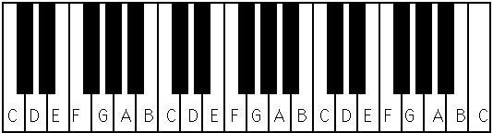

The white keys are named after the first seven letters of the musical alphabet **(ABCDEFG)**. When we play from left to right on the keyboard, we are GOING UP in pitch. As we play from right to left the notes become lower. The white key on the left of two black keys is **C**. Between the two black keys is **D**. To the right of two black keys is **E**. The white key on the left of the three black keys is **F**. **G** and **A** are inside, and **B** is on the right of the three black keys.

Notes on octave apart from each other have the same letter names e.g. A A, C C, G G, etc. A standard piano keyboard has 7 ¼ octaves.

**SEMITONE**

This is the distance between any note and the very next note up or down from it. E.g. B to C, E to F, and G to (*black note on the right of G*) is a semitone.

**A TONE**

This is the distance of two SEMITONES up or down from any given note. E.g C to D , D to E, etc.

Now, look at the note 'G'. The semitone **down** from that note would be the black note which is the lowest of the group of three black notes. We would call that note 'G-flat'. Did you notice? 'F-sharp' and 'G-flat' are the same pitch! All of the black notes on the piano keyboard have two different names. Give two names for the black note which is the middle of the group of three...The answer would be 'G-sharp' and 'A-flat'.

Here is a picture of a keyboard with all of the keys properly labelled, with a staff showing where each note is located. In printed music, we use this sign to indicate 'sharp': mhtml:file://C:\Users\ISRAEL%20SAMSON\Desktop\DLHS%20FILES\theory%20of%20music\The%20Keyboard.mht!http://www.musictheory.halifax.ns.ca/images/sharp_sym.GIF , and this sign to indicate 'flat':  mhtml:file://C:\Users\ISRAEL%20SAMSON\Desktop\DLHS%20FILES\theory%20of%20music\The%20Keyboard.mht!http://www.musictheory.halifax.ns.ca/images/flat_sym.GIF

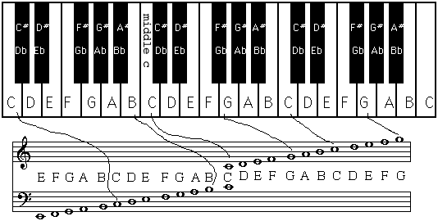

EVALUATION

1. Draw the keyboard.
2. Label the keyboard drawn above.
3. What is semi-tone?
4. What is a tone?

WEEKEND ASSIGNMENT

1. How are the white and black keys arranged?
2. As you play to the right the sound becomes ___ (higher, lower)
3. Mention the two places on the keyboard where semitones exit between white keys only.
4. How many semitones are there in an octave e.g. C to C or D or D?
5. Notes which sound alike but are differently notated (e.g. D# and Eb) are said to be what?

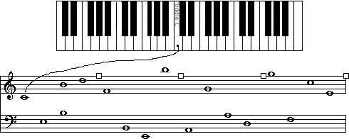

1. Write down the name of the note that is a **semitone above** the following notes.

(There are two possible names):

a) 'G': ______ ______

b) 'C': ______ ______

c) 'A': ______ ______

d) 'D': ______ ______

1. Write down the name of the note that is a **semitone below** the following notes.

(There are two possible names):

a) 'E': ______ ______

b) 'A': ______ ______

c) 'G': ______ ______

**Reference Text:**

Comprehensive music for junior secondary schools, basic 7 by sola Ayodele.

**WEEK 10.**

**TOPIC: RUDIMENTS OF MUSIC.**

**CONTENT**

1. Musical alphabets Clef and names of staves .
2. Musical notes Major scale of **C** natural and Uses of Music.

**SUB-TOPIC 1: MUSICAL ALPHABETS, CLEF AND STAFF**

There are seven musical letters, namely: **A, B, C, D, E, F, G**. These seven letters are called the musical alphabets. They are used to write music.

**CLEF:** A clef can be defined as a musical symbol (sign) written at the beginning of the staff.

There are two major types of clef namely:

Treble clef and Bass clef.

The symbols for treble clef is 

The symbol for Bass clef is .

G clef is also called Treble clef. When G clef sign is placed on the staff, the staff automatically becomes treble staff.



F clef is as well called Bass clef. when the bass clef is placed on the stave, the stave becomes Bass staff.



The names of each of the five lines are shown together with the spaces. Learn the notes of these lines by saying this memory aid: Every Green Bus Drives Fast. The notes in spaces spell out FACE.

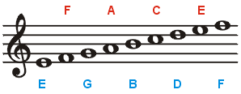

The names of each of the five lines are shown together with the spaces. The following memory aids will help with easy learning for notes of the bass stave: **Green Buses Drive Fast Always** for notes on lines, and **All Cows Eat Grass** for spaces

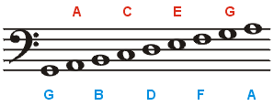

EVALUATION

Give the name of the note on the:

1. 3rd line of the treble stave.
2. 2nd line of the bass stave.
3. 1st line of the treble stave.
4. 1st line of the bass stave.
5. 4th line of the treble stave.

**GREAT/GRAND STAVE:** Two staves joined together with a vertical line on the left (as in pianoscore), with the top staff being treble clef, and the bottom staff being bass. It consist of 11 lines and 10 spaces. Irrespective of the space left between the staves it is important to join the two staves with a brace.

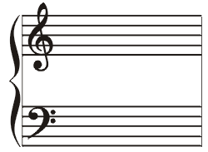

The piano score is written on the two staves of the grand staff. The left hand is used to play notes on the bass stave while the right hand is used to play the notes on the treble stave.

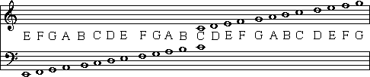

**Evaluation**

Underneath each note, write the correct letter name:

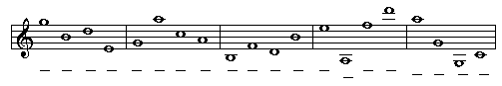

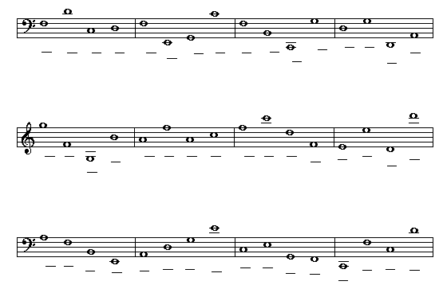

**SUB-TOPIC 2: Musical notes Major scale of C natural and Uses of Music.**

**Musical notes and their relative values**

Musical sounds are represented in writing by symbols called notes which show their values, duration or length. These musical notes are of various shapes.

**Types of Musical Notes:**

There are six principal notes which are in common use nowadays. These notes are shown in the table below:

**MUSICAL NAME, NOTE AND BEAT VALUE**

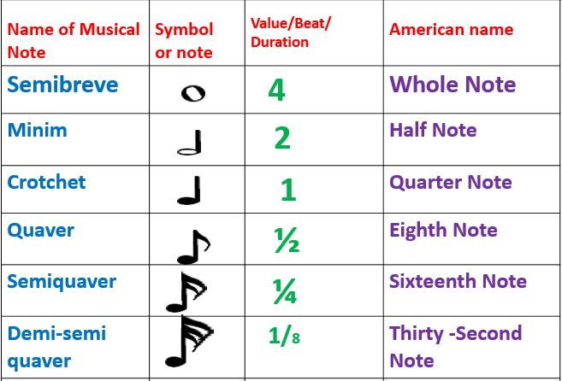

**Relationship of Musical Notes**

The musical notes are related with one another, for example:

1. A Semibreve contains two Minims, four crotchets, eight quavers, sixteen semi- quavers, and thirty- two demisemiquavers.
2. A Minim contains two crotchets, four quavers, eight semiquavers, and sixteen demisemiquavers.
3. A Crotchet contains two quavers, four semiquavers and eight demisemiquavers.
4. A Quaver contains two semi- quavers and four demisemiquavers.
5. A Semiquaver contains two demisemiquavers.

**Evaluation**

1. Write one note that equals the following group of notes:

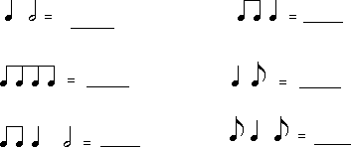

**Major scale of C natural- definition, application.**

In [music theory](http://en.wikipedia.org/wiki/Music_theory), the **major scale** or [Ionian](http://en.wikipedia.org/wiki/Ionian_mode) scale is one of the [diatonic](http://en.wikipedia.org/wiki/Diatonic_scale)[scales](http://en.wikipedia.org/wiki/Musical_scale). It is made up of seven distinct [notes](http://en.wikipedia.org/wiki/Note), plus an eighth which duplicates the first an [octave](http://en.wikipedia.org/wiki/Octave) higher. In solfa notation, these notes correspond to the syllables "Do, Re, Mi, Fa, Soh, La, Ti, (Do)", the "Do". The simplest major scale to [write](http://en.wikipedia.org/wiki/Musical_notation#Modern_musical_notation) or play on the [piano](http://en.wikipedia.org/wiki/Piano) is [C major](http://en.wikipedia.org/wiki/C_major), the only major scale not to require [sharps](http://en.wikipedia.org/wiki/Sharp_%28music%29) or [flats](http://en.wikipedia.org/wiki/Flat_%28music%29), using only the white keys on the piano [keyboard](http://en.wikipedia.org/wiki/Musical_keyboard):

**C Major scale**



**EVALUATION:**

USES OF MUSIC

1. Music is used for social ceremonies such as : marriage, birthday, funeral, graduation, house warming, etc.
2. Music serves as a means of religious worship, for instance, in the churches, mosques , at homes, etc.
3. Music serves as a means of celebrating traditional and contemporary festivals, carnivals, namely: New Yam Festival, Argungun Fishing, Eko Carnival, Eyo Festival, etc.
4. Music is used during teaching-learning in the classroom by the teachers to teach morals and stimulate interest/ excitements while learning.
5. Music is used to lull babies to sleep when crying, such song is called lullaby.
6. Music serves as a means of making advertisements through the television and radio, such song is called jungle.
7. Music serves as agent of change and revolution to human civilization.
8. Music is used at work places and during games sessions by artisans and sport fans to boost morale.
9. Music serves as means of making election campaigns to win supporters.
10. Music serves as means of conveying messages, ideas, concepts, etc. to others in the society.

**EVALUATION:**

1. State any uses of music.

**Reference Text:**

1. Comprehensive music for junior secondary schools , basic 7 by sola Ayodele.
2. Fundamentals of Music, for junior secondary schools, Upper Basic Education 1, Dr.H.C. Nwafor.
3. Spectrum music for schools book 1 by Amorelle Inanga and Glen E. Inanga.

**WEEK 11 REVISION**

**WEEK 12 EXAMINATION**

1.